《数据结构》实验报告
实验编号 |  | 实验名称 | 学生管理系统
实验日期 | 2022 10 8 | 实验教室 | 学海楼 | 指导教师 | 陈波
学 号 | 19210405 | 姓 名 | 王昶宇
一、实验目的和要求：（本次实验所涉及并要求掌握的知识点）
实验题 2.4：用单链表实现一个简易的高校学籍管理系统

二、实验环境：（本次实验所需要的平台和相关软件）
Vs2022
Windows 10
Intel core i5

三、实验内容及步骤：（本次实验计划安排的实验内容和具体实现步骤）
编写”学生.h”并且写好相关函数
创建一个链表类的头文件
将两个头文件之间构建联系，使得其能互通
写主函数，实例化运行程序

四、实验过程和结果：（记录实验过程和结果、以及所出现的问题和解决方法）
先增加一个学生

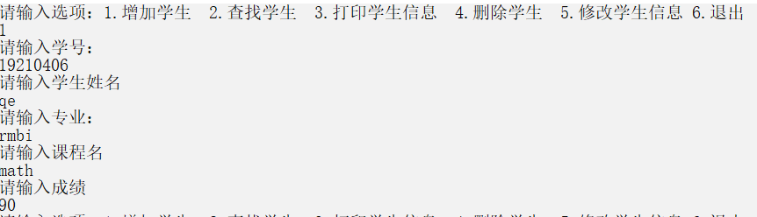
再查找他
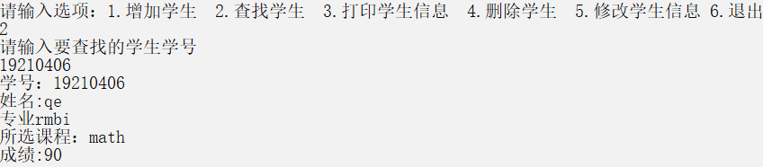
再遍历链表输出所有学生
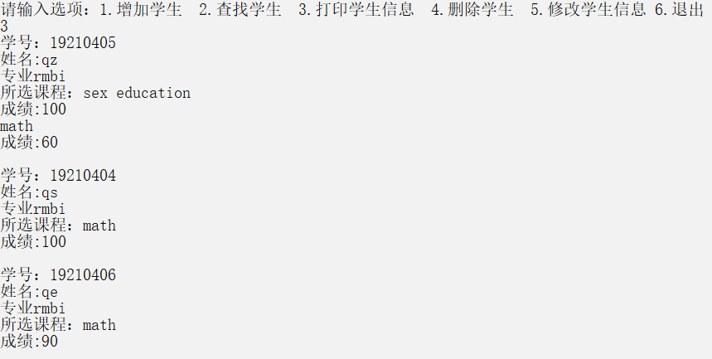
再删除这个新加入的学生
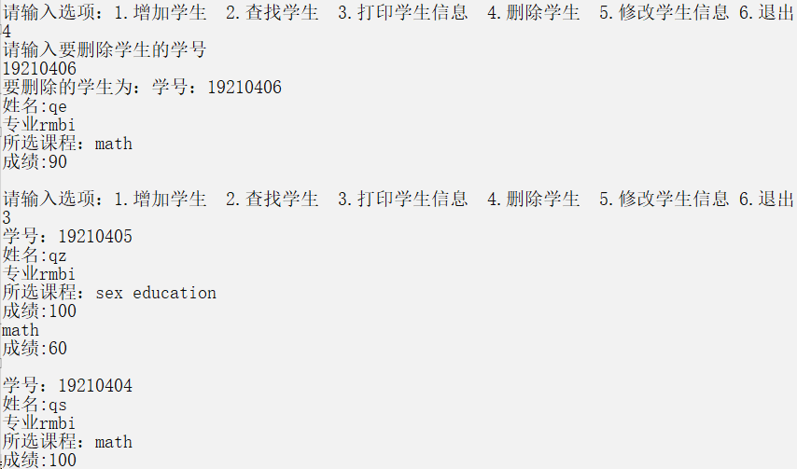
遍历后发现他已经不在全部学生里了

再修改一下学生信息
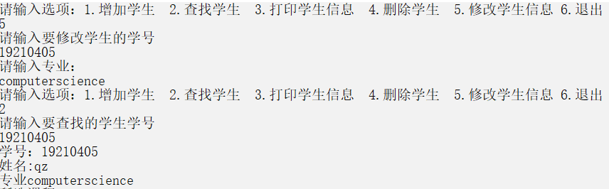
五、实验中的问题及解决：（本次实验中在编程中碰到的错误等问题及解决方法）
1.一开始在设计成绩的时候，用了成绩类，然后让学生类继承它但后来发现不会传参，遂止
然后把成绩对象当成学生类的一个成员，但是没法灵活增加删除，遂止
解决办法：最后想到了可以用链表写一个结构体的成绩，然后就能自由的增添删改了。
2.在修改学生信息时，如果在输入专业时打了空格会进入死循环
解决办法：把cin改成了getline（cin，Major）
六、实验总结和思考：（填写收获和体会，分析成功或失败的原因）：
学会了使用链表，感到成就感
附件：程序源代码
Student.h：
#pragma once
#include<iostream>
#include"LinkList.h"
#include<string>
using namespace std;

/*失败品class Course
{
string CourseName;
int grade;
public:
Course();
Course(string n=NULL, int s=0) :CourseName(n), grade(s){}
void AddName(string n)
{
CourseName = n;
}
void InName()
{
cout << "请输入课程名" << endl;
cin >> CourseName;
}
void InGrade()
{
cout << "请输入成绩：" << endl;
cin >> grade;
}
void AddGrade(int s)
{
grade = s;
}
int SearchGrade()
{
return grade;
}
};*/
struct Course
{
string CourseName;
int grade;
Course* next;
};
class Student
{
int ID;
string Name;
string Major;
Course* head;
public:
Student();
Student(int id, string n, string m);
bool operator ==(Student student);
bool operator ==(int n);
bool operator !=(Student student);
void InName()
{
cout << "请输入学生姓名" << endl;
cin >> Name;
}
void InID()
{
cout << "请输入学号：" << endl;
cin >> ID;
}
void InMajor()
{
cout<< "请输入专业：" << endl;
getline(cin, Major);
}
void ChangeID(int id)
{
ID = id;
}
void AddName(string n)
{
Name = n;
}
void AddMajor(int m)
{
Major = m;

}
void SetCourse(string n,int score)
{
Course* p = new Course;
p->CourseName = n;
p->grade = score;
p->next = head->next;
head->next = p;
}
void InCourse()
{
Course* p = new Course;
cout << "请输入课程名" << endl;
cin>>p->CourseName;
if (!cin.good())
cerr << "输入的格式有误" << endl;
cout << "请输入成绩" << endl;
cin>>p->grade;
if (!cin.good())
cerr << "输入的格式有误" << endl;
p->next = head->next;
head->next = p;
}
void Print()
{
cout << "学号：" <<ID<< endl;
cout << "姓名:" << Name << endl;
cout << "专业" << Major << endl;
cout << "所选课程：";

Course* p = head->next;
while (p)
{
cout << p->CourseName << endl;
cout <<"成绩:" << p->grade << endl;
p = p->next;

}
}
friend ostream& operator << (ostream& out, Student& student);

};
Student::Student()
{
head = new Course;
head->next = NULL;
}
Student::Student(int id, string n, string m)
{
ID = id;
Name = n;
Major = m;
head = new Course;
head->next = NULL;
head->grade = 0;
head->CourseName = "noname";

}
ostream& operator <<(ostream& out, Student& student)
{
out << "学号：" << student.ID << endl;
out << "姓名:" << student.Name << endl;
out << "专业" << student.Major << endl;
out << "所选课程：";

Course* p = student.head->next;
while (p)
{
out << p->CourseName << endl;
out << "成绩:" << p->grade << endl;
p = p->next;

}
return out;
}
bool Student::operator==(Student student)
{
return ID == student.ID;
}
bool Student::operator==(int n)
{
return ID == n;
}
bool Student::operator!=(Student student)
{
return ID != student.ID;
}

LinkList.h:
#pragma once
#include <algorithm>
#include <iostream>
#include"Student.h"
using namespace std;

template <class T>//结点
struct Node
{
T data;
Node<T>* next;
};

template <class T>
class LinkList
{
public:
LinkList();
LinkList(T a[], int n);
~LinkList();
int Length();
T Get(int pos);//按位查找
void Change(int id);
int Locate(T x);//按值查找
void Insert(int i, T item);//插入
T Delete(int i);//删除
void PrintList();//打印
void Invert();//逆置
friend void Merge(LinkList<T>& L1, LinkList<T>& L2);//归并
friend class Student;
private:
Node<T>* head;
};

template <class T>
LinkList<T> ::LinkList()
{
head = new Node<T>;
head->next = NULL;
}

template <class T>
LinkList<T> ::LinkList(T a[], int n)
{
head = new Node<T>; Node<T>* rear = head;
for (int i = 0; i < n; i++)
{
Node<T>* s = new Node<T>; s->data = a[i];
rear->next = s; rear = s;
}
rear->next = NULL;

/*头插法
head = new Node<T>;

for (int i = 0; i < n; i++)
{
Node<T> *p = new Node<T>;
p->data = a[i];
p->next = head->next;
head->next = p;

}*/
}
template <class T>
LinkList<T>:: ~LinkList()
{
Node<T>* p = head;
while (p)
{
Node<T>* q = p;
p = p->next;
delete q;
}
head = NULL;
}

template <class T>
int LinkList<T>::Length()
{
int length = 0;
Node<T>* p = head->next;
while (p)
{
p = p->next;
length++;

}
return length;
}

void LinkList<Student>::Change(int id)
{
Node<Student>* p = head->next;

while (p)
{
if (p->data == id)
{

p->data.InMajor();
break;
}
else
p = p->next;

}
}
template <class T>
T LinkList<T> ::Get(int pos)
{
Node<T>* p = head->next;

while (p)
{
if (p->data == pos)
{
cout << p->data << endl;
return p->data;
}
else
p = p->next;

}

}
template<class T>
int LinkList<T>::Locate(T x)
{
Node<T>* p = head->next;
int pos = 1;
while (p && p->data != x)
{
p = p->next;
pos++;
}
if (p)
return pos;
else
return -1;
}
template<class T>
void LinkList<T>::PrintList()
{
Node<T>* p = head->next;
while (p)
{
cout << p->data << endl;
p = p->next;

}

}
template<class T>
void LinkList<T>::Insert(int i, T item)
{
Node<T>* p = head;
int j = 0;
while (p && j < i - 1)
{
p = p->next;
j++;
}
if (!p)
{
cerr << "插入位置非法";
exit(1);
}
else
{
Node<T>* s = new Node<T>;
s->data = item;
s->next = p->next;
p->next = s;
}

}
template <class T>
T LinkList<T>::Delete(int i)
{
Node<T>* p = head;

while (p)
{
if (p->next->data == i)
{
Node<T>* q = p->next;
T x = q->data;
p->next = q->next;
delete q;
return x;
}
else
p = p->next;

}

}
template<class T>
void LinkList<T>::Invert()
{
Node<T>* p = head->next;
Node<T>* q = new Node<T>;
head->next = NULL;
while (p != NULL)
{
q = p;
p = p->next;
q->next = head->next;//将节点插入到逆置后单链表的表头
head->next = q;
}
}

//template<class T>
void Merge(LinkList<int>& L1, LinkList<int>& L2)
{
Node<int>* p1 = L1.head->next;
Node<int>* p2 = L2.head->next;
Node<int>* p3 = L1.head;
while ((p1 != NULL) && (p2 != NULL))
{ //处理两个表非空时的情况。p1，p2指向当前需比较的结点，
//p3指向结果有序单链表的表尾
if ((p1->data) < (p2->data))
{
p3->next = p1; p1 = p1->next;
p3 = p3->next;
}
else
{
p3->next = p2; p2 = p2->next;
p3 = p3->next;
}
}
if (p1 != NULL) p3->next = p1;
if (p2 != NULL) p3->next = p2;
delete L2.head; L2.head = NULL;

}

学生管理系统.cpp:
#include <iostream>
#include"LinkList.h"
#include"Student.h"
using namespace std;

int main()
{

LinkList<Student> hkust;

Student qz(19210405, "qz", "rmbi");
Student qs(19210404, "qs", "rmbi");
qz.SetCourse("math", 60);
qz.SetCourse("sex education", 100);
qs.SetCourse("math", 100);
hkust.Insert(1, qz);
hkust.Insert(2, qs);
int num = 3;

while (1)
{cout << "请输入选项：1.增加学生 2.查找学生 3.打印学生信息 4.删除学生 5.修改学生信息 6.退出" << endl;
int sel;
cin >> sel;

switch (sel)
{
case 1:
{
Student who;
who.InID(); who.InName(); who.InMajor(); who.InCourse();
hkust.Insert(num, who);
num++;
}break;
case 2:
{
int n;
cout << "请输入要查找的学生学号" << endl;
cin >> n;
hkust.Get(n);
}
break;
case 3:
{
hkust.PrintList();
}break;
case 4:
{
int i;
cout << "请输入要删除学生的学号" << endl;
cin >> i;
cout << "要删除的学生为："; hkust.Get(i);
hkust.Delete(i);

}break;
case 5:
{
int i;
cout << "请输入要修改学生的学号" << endl;
cin >> i;
hkust.Change(i);

}break;
case 6:
{
exit(1);
}break;

}

}
}
评阅意见

